DSA Project
“SellSpot”



Session 2024 - 2028
Submitted by:
Areeb Ali 2024-CS-98
M. Zain Ijaz 2024-CS-107
Muhammad Saad 2024-CS-67
M. Furqan Mustafa 2024-CS-100
Supervised by:
Ms. Rabeeya Saleem

Course:
Data Structure and Algorithms

Department of Computer Science
University of Engineering and Technology, Lahore Pakistan

1. Project Title:
“SellSpot”
2. Abstract
Sell Spot is a console-based classified marketplace platform developed to address the common problem faced by individuals who want to sell their used goods conveniently from home. The main objective of this project is to provide a simple, structured, and efficient system where users can list products for sale, manage accounts, and interact within a controlled environment, while administrators monitor activities such as pending advertisements and reported users. The project emphasizes the practical application of Data Structures and Algorithms (DSA) concepts by organizing users and products using appropriate data structures and applying logical processing for management and moderation tasks. The scope of the project includes user and admin functionalities, product handling, and system-level operations, demonstrating how DSA can be effectively used to build a real-world marketplace application.
3. Tools / Language / IDE
Category | Details (As per Project Files)
Programming Language | C# (C-Sharp)
Platform / Framework | .NET Framework
IDE (Integrated Development Environment) | Microsoft Visual Studio
Compiler | C# Compiler (Roslyn – built into Visual Studio)
UI | Window Presentation Form (WPF)
Project Type | Desktop Application
Operating System | Windows (recommended for Visual Studio and .NET execution)
4. System Design
4.1 High-Level Architecture / Flow Diagram (Explanation)
Based strictly on the uploaded project files and their structure, the system is divided into the following main layers:
- User Interface (UI) Layer
- Acts as the interaction point between the user and the system.
- Takes input from users (such as login details, product information, and menu choices).
- Displays outputs like product listings, user details, and system messages.
- Business Logic (BL) Layer
- Contains the core logic of the application.
- Classes such as UserBL, AdminBL, and ProductBL etc manage rules related to users, administrators, and products.
- Ensures validation, processing, and decision-making before data is stored or retrieved.
- Data Layer (DL)
- Responsible for data storage and retrieval.
- Ensures that data remains consistent across multiple executions of the program.
System Architecture Design:
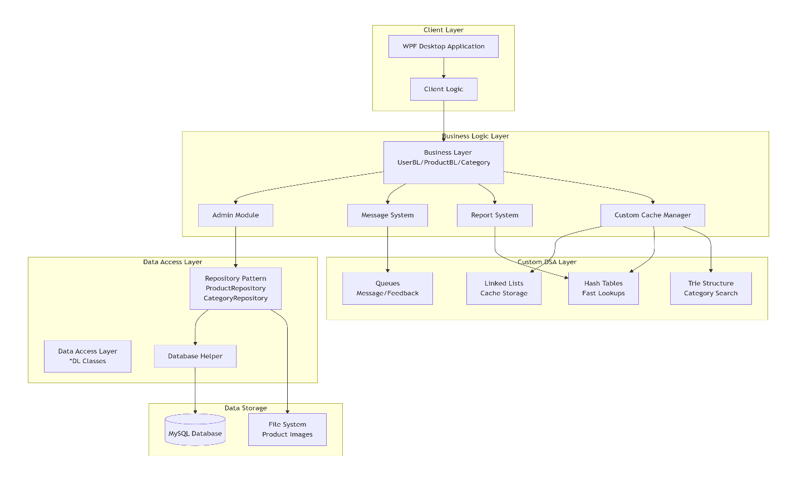
Flow Diagram:
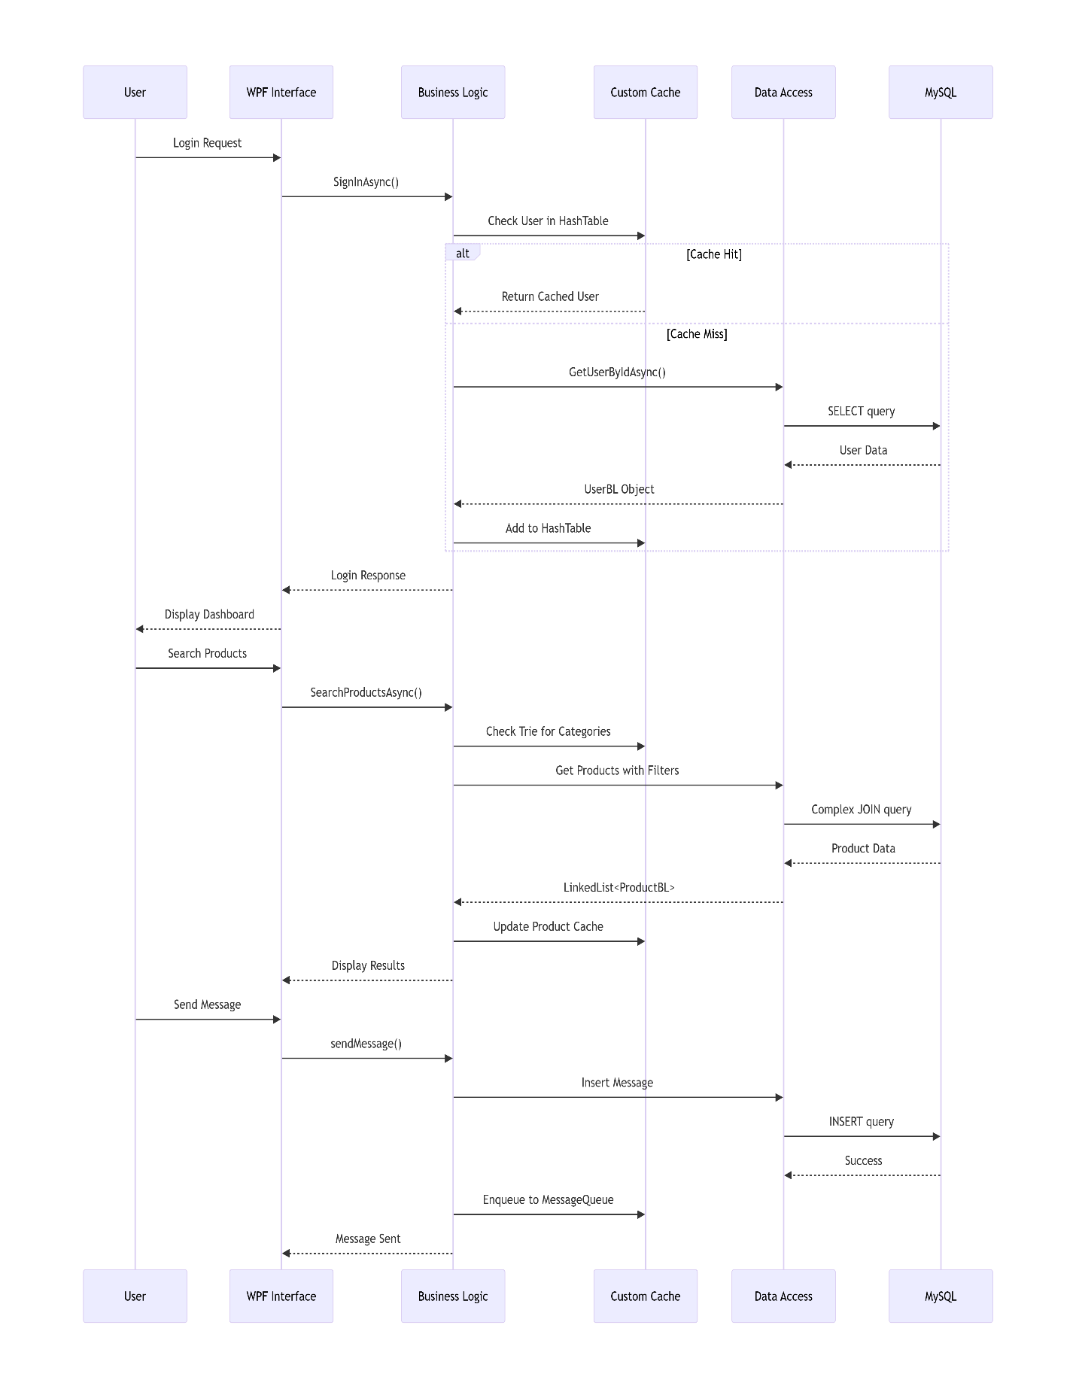
4.2 Data Structures Used in this Project
The "Sell Spot" platform utilizes a variety of custom and built-in data structures to manage marketplace data efficiently, ranging from linear structures for messaging to non-linear structures for category hierarchies.
1. Linked Lists
- Purpose: Used as the primary collection for managing dynamic data where frequent insertions and deletions occur, such as product listings and user records.
- Implementation: * A Custom Doubly Linked List (CustomLinkedList<T>) is implemented in UserBL.cs to store UserBL, MessageBL, and ProductBL objects. It supports efficient additions to both the head and tail.
  - The ProductRepository uses the built-in LinkedList<ProductBL> to cache products, allowing for efficient memory management of the marketplace inventory.
  - AdminBL uses LinkedList to manage PendingAdds and ReportedUserd.
2. Queues (Linear Data Structure)
- Purpose: Used for managing data in a First-In-First-Out (FIFO) manner, which is essential for communication and feedback systems.
- Implementation:
  - FeedbackQueue: Manages customer feedback and complaints in the order they are received.
  - MessageQueue: Handles real-time messaging between buyers and sellers, ensuring that conversations are processed and displayed in the correct chronological order.
Stack:
Purpose: Provides undo functionality for actions like editing an ad or deleting a message.
3. Hash Tables / Dictionaries
- Purpose: Used for high-performance data retrieval and mapping unique keys to specific objects, such as looking up categories or grouping chat partners.
- Implementation:
  - CustomHashTable: A custom implementation in CategoryBL.cs uses the DJB2 hashing algorithm and a bucket-based collision handling strategy to store and retrieve data with an average time complexity of .
  - CustomLinkedDictionary: Combines hash table speed with linked list ordering.
  - HashSet: Used in MessageQueue.cs to identify unique chat partners by their User IDs.
4. Trees / Hierarchical Structures
- Purpose: Used to represent the marketplace's category and sub-category organization.
- Implementation: * Categories are structured as a General Tree where each CategoryBL object contains a List<CategoryBL> SubCategories and a reference to its Parent. This allows for a multi-level hierarchy (e.g., Electronics → Mobile Phones → Smartphones).
4.3 Justification of Data Structure Choice
The choice of these data structures is tailored to the specific functional requirements of a classified marketplace:
- Why Custom Linked List Fits:
  - In a marketplace, users frequently add or remove product listings. A linked list is ideal because it allows for O(1) insertions and deletions at the head or tail, which is more efficient than shifting elements in an array-based list.
- Why Queue (FIFO) Fits:
  - Messaging and feedback systems must preserve the chronological order of interactions. A Queue ensures that the first message sent is the first one displayed or processed, maintaining a logical flow of conversation between users.
- Why Custom Hash Table Fits:
  - The project requires quick retrieval of categories, users, or products by their unique identifiers. The CustomHashTable uses the DJB2 hash algorithm to minimize collisions and provide near-constant time (O(1)) performance for search operations.
- Why Custom Linked Dictionary Fits:
  - This is particularly useful for features like "Recent Chats" or "Latest Listings," where the system needs to find an item instantly (via the Hash Table) but also needs to display them in a specific order (via the Linked List).
- Why Doubly Linked Nodes Fit:
The use of Prev and Next pointers in the CustomLinkedList allows the application to traverse data in both directions (e.g., navigating through a list of images or chat history), providing more flexibility than a singly linked list.
- Why a Generic Tree fits the problem:
  - Natural Representation: Marketplace categories are inherently hierarchical. A tree structure perfectly maps this real-world relationship where one root category can have multiple subcategories, which in turn can have their own sub-categories.
  - Recursive Traversal: The tree structure allows the system to perform recursive operations easily, such as calculating the total number of products in a parent category by summing up products in all its descendant subcategories.
  - Efficient Filtering: It enables efficient "drilling down" into specific niches. Instead of searching through all products, the tree structure allows the system to narrow down the search space to a specific branch (category path), improving the user's browsing experience.
4.4 Module Breakdown
The project follows a modular architecture, separating data structures, core business logic, and data access operations.
1. Data Structures Module
This module contains custom-implemented data structures designed to handle the marketplace's specific data flow requirements.
- CustomLinkedList<T>:
  - Responsibilities: Provides a generic, doubly-linked list implementation with nodes that track both Next and Prev references. It manages dynamic collections for various business entities where frequent addition and removal are required.
- MessageQueue:
  - Responsibilities: Implements a First-In-First-Out (FIFO) queue specifically for MessageBL objects. It handles enqueuing new messages, dequeuing processed ones, and grouping messages into individual chats for user-to-user communication.
- FeedbackQueue:
  - Responsibilities: Manages a queue for user feedback and ratings. It supports adding feedback to the rear of the queue and removing specific feedback entries by their ID.
2. Business Logic Layer (BL)
These classes define the core entities and the rules for interacting with them.
- UserBL:
  - Responsibilities: Represents a user within the system and manages their profile data. It contains custom sorting logic, such as a QuickSort implementation to organize users by their registration date.
- ProductBL:
  - Responsibilities: Defines the product entity, including its price, condition (New, Used, Refurbished), status (Available, Pending, Sold), and location. It also includes extension methods for sorting product lists by price.
- CategoryBL:
  - Responsibilities: Manages the hierarchical organization of products. Each category acts as a node in a Tree structure, maintaining a reference to its parent and a list of subcategories. It also implements a custom hash code using the DJB2 algorithm for efficient identification.
- AdminBL:
  - Responsibilities: A specialized version of UserBL that includes additional collections for administrative oversight, specifically tracking reported users and products pending approval in linked lists.
- MessageBL:
  - Responsibilities: Represents a single communication between a sender and a receiver, often linked to a specific product. It manages message state (like IsRead) and provides methods to retrieve unread messages or full chat histories.
- FeedbackBL:
  - Responsibilities: Handles user-submitted ratings and reports. It includes validation logic to ensure ratings are within the 1–5 range and that reports are correctly linked to a reported user.
- ReportsBL:
  - Responsibilities: Specifically manages the data for user complaints and system reports, including the reason for the report and its resolution status.
Data Access Layer (DAL) / Data Logic (DL)
- These modules bridge the gap between the application's business logic and the MySQL database.
- DatabaseHelper:
  - Responsibilities: Manages the low-level database connection (MySQL) and provides "SafeGet" helper methods (e.g., SafeGetInt, SafeGetString) to handle null values from the database without crashing the application.
- MessageDL:
  - Responsibilities: Executes SQL queries to save, retrieve, and delete messages from the database. it populates the MessageQueue with fresh data from the database.
- FeedbackDL:
  - Responsibilities: Handles database operations for feedback and ratings. It retrieves recent reviews and inserts new reports into the system.
- AdminStatistics:
  - Responsibilities: Acts as a Data Transfer Object (DTO) to aggregate dashboard data, such as the total count of users, products, and pending reports for the administrator's view.
5. Detailed Implementation
5.1 Key Classes / Structures (fields, methods)
The project utilizes several primary classes that serve as the backbone for both data storage and business logic:
- ProductBL (Key Entity)
  - Fields: ProductId, Title, Price, Condition, Status, CategoryId, SellerId, Location, ImagePaths (List).
  - Methods: GetProductById(), AddProduct(), UpdateProduct(), DeleteProduct(), and extension methods like SortByPrice() and GetProductsWithImages().
- UserBL (User Management)
  - Fields: UserId, Username, Email, Password, Role, CreatedAt.
  - Methods: Login(), Register(), GetUserById(), CustomQuickSort() (for sorting users by date).
- MessageQueue & FeedbackQueue (Custom Data Structures)
  - Fields: front (Head node), rear (Tail node).
  - Methods: Enqueue(), Dequeue(), Peek(), IsEmpty(), ToList().
- CategoryBL (Hierarchical Structure)
  - Fields: CategoryId, Name, ParentId, SubCategories (List), Products (List).
  - Methods: GetHashCode() (using DJB2 algorithm), GetAllProductsInHierarchy(), IsDescendantOf().
- CustomLinkedList<T> (Generic Structure)
  - Fields: head, tail, count.
  - Methods: AddFirst(), AddLast(), Remove(), Find().

5.2 Core Operations
The system implements fundamental Data Structure and Database operations across all modules:
- Insert:
  - Queue: Enqueue() method adds new messages or feedback to the rear of the queue.
  - Linked List: AddLast() adds products or reports to the end of the list O(1)).
  - Database: SQL INSERT statements in MessageDL and FeedbackDL persist new data.
- Delete:
  - Queue/List: Dequeue() removes from the front. The RemoveFeedback(id) method traverses the queue to find and remove a specific node (O(n)).
  - Database: DeleteFromDataBase(id) in MessageDL removes records based on Primary Keys.
- Search:
  - Linear Search: Used in Find() methods of custom collections to locate specific objects by ID.
  - Hashing: The GetHashCode() in CategoryBL allows for fast identification of category objects.
- Update:
  - Implemented via setter properties and specialized methods like markRead() in MessageBL, which updates the IsRead status of a message.
- Traverse:
  - Recursive Traversal: Used in CategoryBL to navigate through the category tree and retrieve all products in a hierarchy.
  - Linear Traversal: Used in the ToList() methods of the Queues to convert linked nodes into a displayable list format.
- Sorting:
  - QuickSort: A custom implementation in UserBL used to sort user lists.
  - Comparison Sorting: Used in ProductBL via SortByPrice to organize listings for the user.
5.3 Libraries / Dependencies
The project is built using the .NET framework and relies on specific libraries for data persistence and UI management:
- MySql.Data.MySqlClient: The primary dependency used for connecting the C# application to the MySQL database. It handles command execution and data reading through MySqlConnection and MySqlDataReader.
- System.Data: Used for managing DataTable and DataRow objects when fetching bulk data from the database.
- System.Collections.Generic: Used for standard collections like List<T> and LinkedList<T> where custom structures aren't strictly required.
6. Complex Analysis
This analysis evaluates the efficiency of the custom data structures and algorithms used to handle marketplace operations like messaging, category management, and user sorting.
6.1 Time Complexity
The time complexity varies based on the data structure and the specific operation being performed:
Module / Operation | Algorithm / Structure | Best Case | Average Case | Worst Case
Messaging/Feedback | Queue (Enqueue/Dequeue) | O(1) | O(1) | O(1)
User Sorting | Custom QuickSort | O(n \log n) | O(n \log n) | O(n^2)
Category Lookup | Custom Hashing (DJB2) | O(1) | O(1) | O(n)
Product Navigation | Generic Tree Traversal | O(1) | O(\log n) | O(n)
List Search | Linear Search (Linked List) | O(1) | O(n) | O(n)
6.2 Space Complexity
The space complexity analysis focuses on how much extra memory the system requires relative to the input size (n):
Component / Data Structure | Space Complexity | Justification
CustomLinkedList<T> | O(n) | Stores n elements, where each node requires additional memory for Next and Prev pointers.
MessageQueue (FIFO) | O(n) | Space grows linearly with the number of messages stored in the queue.
FeedbackQueue (FIFO) | O(n) | Linear space requirements for storing user feedback and report nodes.
CategoryBL (Generic Tree) | O(n) | The hierarchical structure stores n categories across various levels.
CustomQuickSort (Sorting) | O(\log n) | Requires logarithmic space on the call stack due to recursive partitioning.
CustomHashTable<T> | O(n + m) | Space depends on the number of elements (n) and the size of the bucket array (m).
ProductBL (List/Array) | O(n) | Storing product attributes and lists of image paths grows linearly with the data size.
7. Testing & Results
7.1 Test Strategy
The testing strategy for the Sell Spot platform focused on validating the custom-built Data Structures and the Business Logic to ensure data integrity and system stability. The following methods were used:
- Unit Testing of Data Structures: Each custom structure (MessageQueue, FeedbackQueue, and CustomLinkedList) was tested independently to ensure that Enqueue, Dequeue, AddLast, and Remove operations functioned correctly without losing pointers.
- Algorithm Validation: The CustomQuickSort in the User module was tested with both empty lists and lists containing thousands of users to verify its O(n \log n) performance and stability.
- Integration Testing: Validating the connection between the DatabaseHelper and the Business Logic layers to ensure "SafeGet" methods correctly handled NULL values from the MySQL database.
7.2 Test Cases Table
Test Case ID | Feature | Scenario / Input | Expected Result | Result
TC-01 | Messaging | Enqueue a message to MessageQueue. | Message is added to the rear and front remains unchanged. | Pass
TC-02 | Categories | Search for a non-existent Category ID. | System returns null or empty list without crashing. | Pass
TC-03 | User Sorting | Sort 0 users using CustomQuickSort. | System handles empty list gracefully. | Pass
TC-04 | Feedback | Dequeue from an empty FeedbackQueue. | Returns null and prevents null pointer exception. | Pass
TC-05 | Product Status | Change status to "Sold". | Product remains in list but status updates in DB. | Pass
TC-06 | Hashing | Compute DJB2 hash for two identical strings. | Both strings produce the exact same hash value. | Pass
TC-07 | Data Access | Database connection timeout. | DatabaseHelper catches the exception and returns false. | Pass
ScreenShots:
Login:
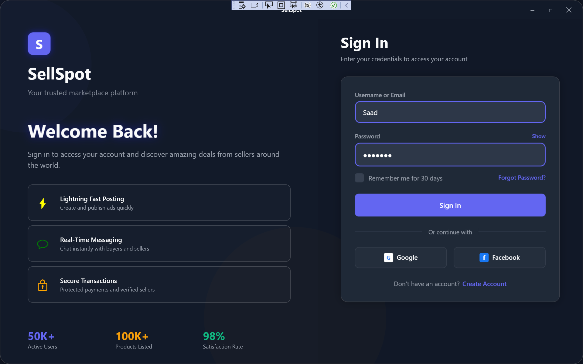
Products:
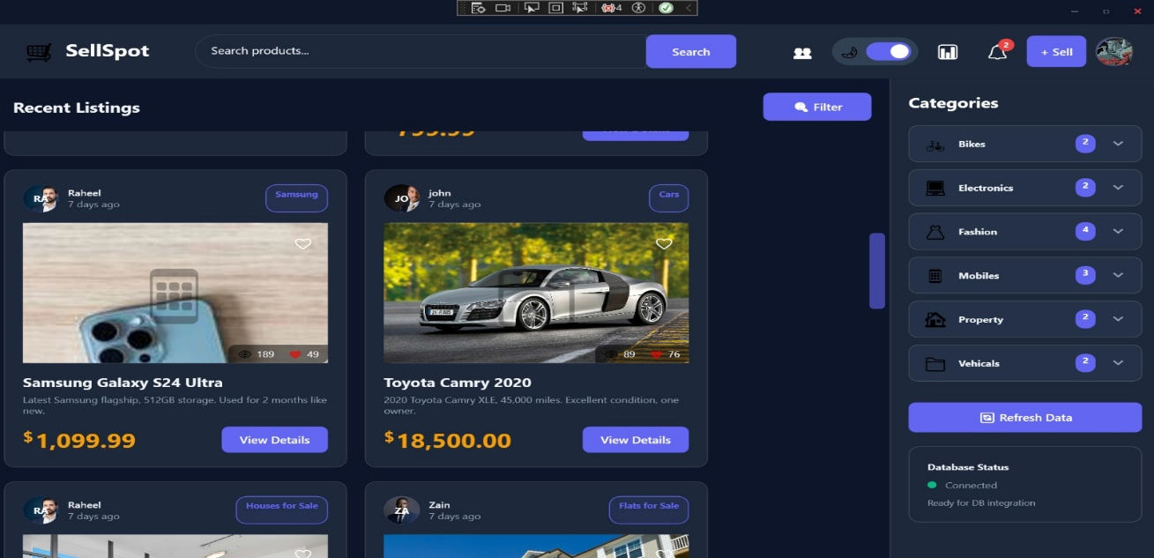
Messages:
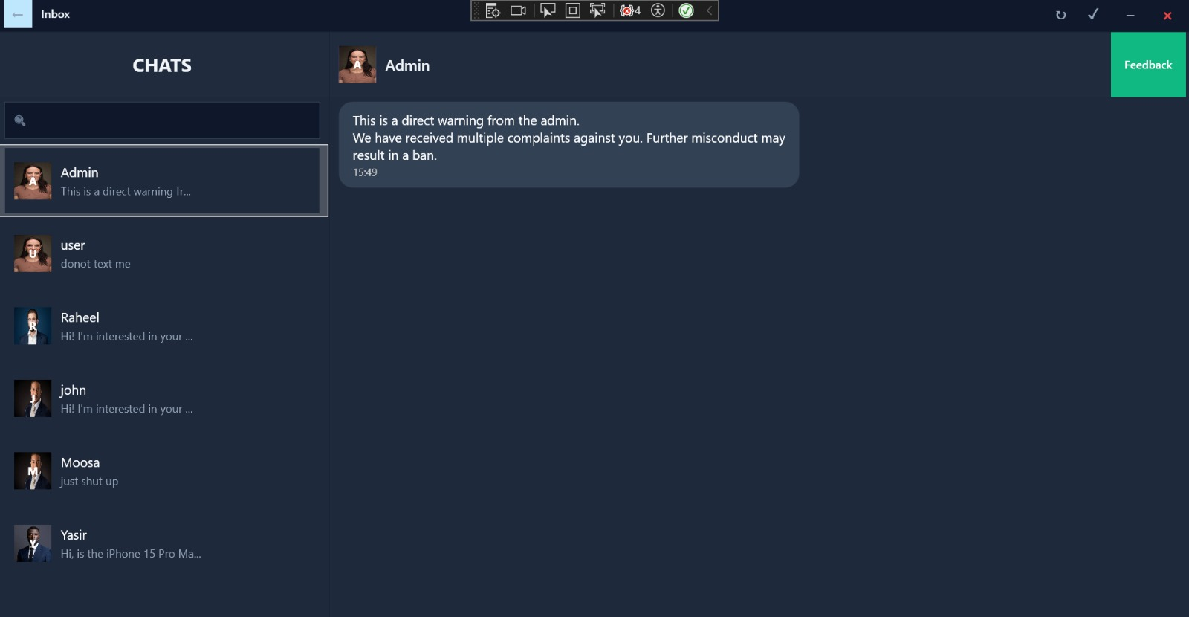
8. User Guide
8.1 How to Compile/Run
To set up and run the Sell Spot application, follow these steps:
- Prerequisites:
  - Install Visual Studio 2022 or later.
  - Install .NET 6.0/7.0 SDK (depending on your project target).
  - Install MySQL Server or ensure you have access to the remote database (sql.freedb.tech) mentioned in DatabaseHelper.cs.
- Database Configuration:
  - Ensure the connection string in DatabaseHelper.cs is active.
  - If using a local database, run the SQL script to create the users, products, messages, and feedback tables.
- Compilation:
  - Open the solution file (.sln) in Visual Studio.
  - Go to Build > Build Solution (or press Ctrl+Shift+B).
  - Ensure all dependencies like MySql.Data are restored via NuGet Package Manager.
- Execution:
  - Set the UI project (WPF) as the Startup Project.
  - Press F5 or click the Start button to run the application.
8.2 How to Use (Menu/Options/Commands)
The application provides different interfaces based on the user's role:
A. Authentication & Profile:
- Register: Create a new account.
- Login: Access the platform using email/username and password.
B. Buyer/Seller Features:
- Home/Browse: View all available products organized by categories (using the Tree structure).
- Post Ad: Add a new product listing (adds to the Pending List for admin approval).
- Chat: Send and receive messages. The system uses a Message Queue to organize your conversations.
- Favorites: Add products to your wishlist for later viewing.
C. Admin Dashboard:
- Manage Products: Approve or reject pending ads from the PendingAdds Linked List.
- Reports: Review user reports stored in the ReportsBL Linked List and mark them as solved.
- Statistics: View total users and platform activity via the AdminStatistics dashboard.
8.3 Sample Run (Input/Output)
Below is a walkthrough of a typical user scenario:
Scenario: User Posting and Buying a Product
- Input (User A - Seller):
  - Action: Clicks "Post Ad".
  - Input Data:
    - Title: "Used MacBook Pro"
    - Price: 1200
    - Category: "Electronics > Laptops" (Tree Selection)
  - System Internal: Product is added to the PendingAdds Linked List.
- Output (Admin View):
  - Display: The Admin sees the MacBook Pro in the "Pending" section.
  - Action: Admin clicks "Approve".
  - Result: Status changes from Pending to Available.
- Input (User B - Buyer):
  - Action: Searches "MacBook" and clicks on the product.
  - Input Data: Sends message: "Is the price negotiable?"
- Output (Chat System):
  - System Internal: Message is Enqueued into the MessageQueue.
  - Display: User A receives a notification; the message appears at the top of their chat list (FIFO order).

